**Mitigation Blocks**

M pattern, swing failure

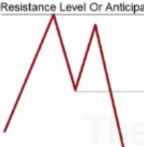 **led Bearilh lnllllU1JOflal R11-4 Poirll**

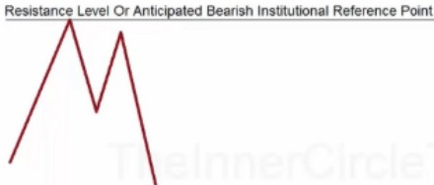

**Support l-' Or Anbelpaltd Bulbh lnll,lrtullon,1!Ret.renc:, POlnt**

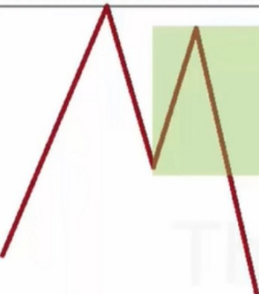

**SUpporl L-' Of Anbc!p9tecl Bulllltl lnstitvtionel Reference Point**

**Resistance Level Or Anticipated Bearish Institutional Reference Point**

**This Short Term Rally In Price Highlights a Specific Institutional Reference Point Known As The "Mitigation Block"**

Support Level Or Anticipated Bullish Institutional Reference Point

Inside that range have been buyers, but those buyers are now underwater

Resistance Level Or Antici ated Bearish Institutional Reference Point

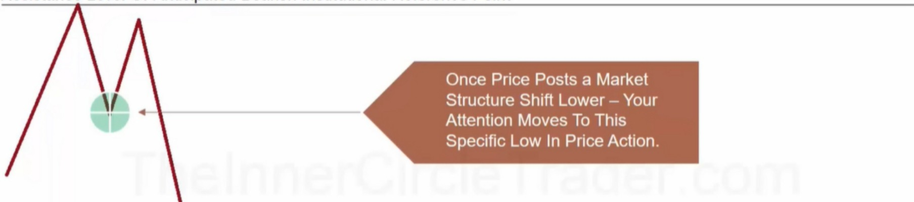

Support Level Or Anticipated Bullish Institutional Reference Point

Inside that low, we will be focusing on the last down candle, because thats where the last orders where placed before the short rally up

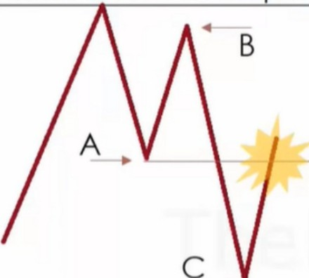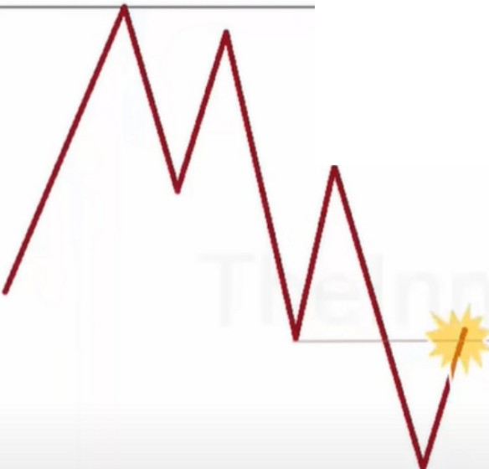Resistance Level Or Antici ated Bearish Institutional Reference Point

When Price Action Returns To The "A" Point Of Reference - The Long Positions Taken From "A" to "B" Price Swing Will Have An Opportunity To Liquidate Or "Mitigate" The Net Loss That Occurred When Price Dropped From "B" To "C". This Can Result In New Lower Price Swings To "C" For Retesting. Or

* Significantly Lower Prices Into The Support Level Under Market Price.

Support Level Or Anticipated Bullish Institutional Reference Point

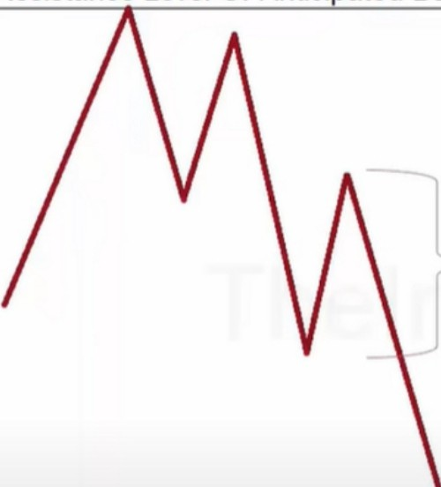Resistance Level Or Antici ated Bearish Institutional Reference Point

Do The Longs In Here Need Mitigated?

Support Level Or Anticipated Bullish Institutional Reference Point

If we anticipate prices going even lower, then we can use that as another selling opportunity

Resistance Level Or Anticipated Bearish Institutional Reference Point

Support Level Or Anticipated Bullish Institutional Reference Point

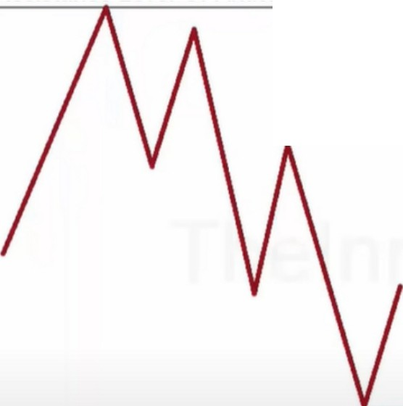

◄

Short Opportunity

Support Level Or Anticipated Bullish Institutional Reference Point

Resistance Level Or Anticipated Bearish Institutional Reference Point

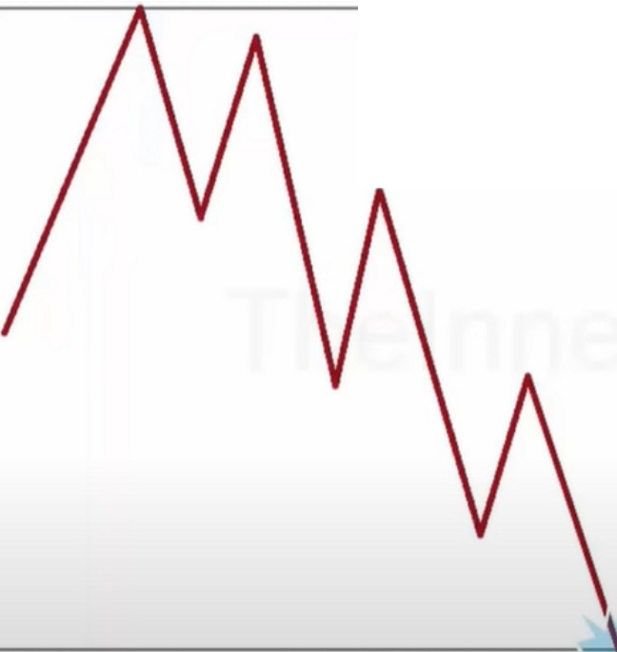

Support Level Or Anticipated Bullish lnsti! tior;,I Reference Point

Collapse the trade and wait for new developments

Resistance Level Or Antici ated Bearish Institutional Reference Point

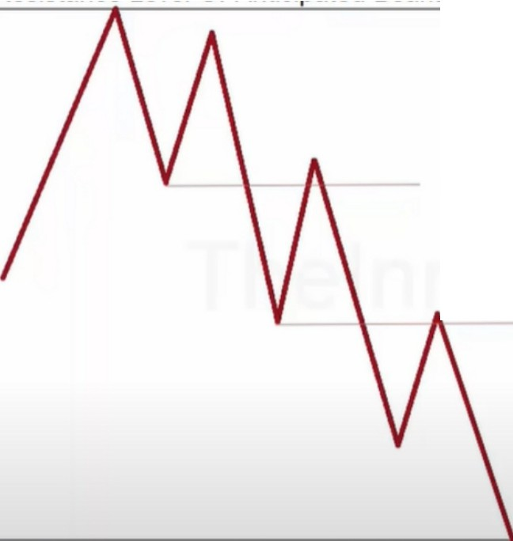

Buyers

Remorse

Buyers Remorse

**C ass·c S ppo Broke T r s**

**es·s a ce**

Support Level Or Anticipated Bullish Institutional Reference Point

Its refered to as buyers remorse

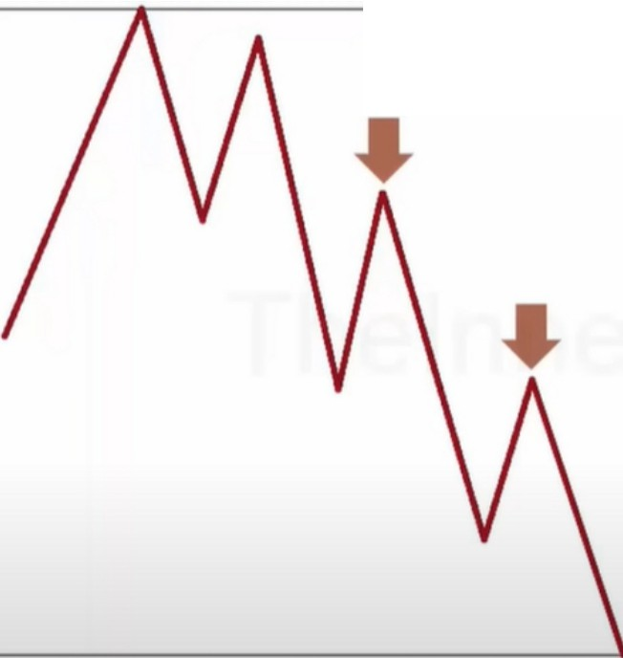**Premium Price Highs**

**Are Bought By Less Informed Traders & Sold By Smart Money**



Support Level Or Anticipated Bullish Institutional Reference Point

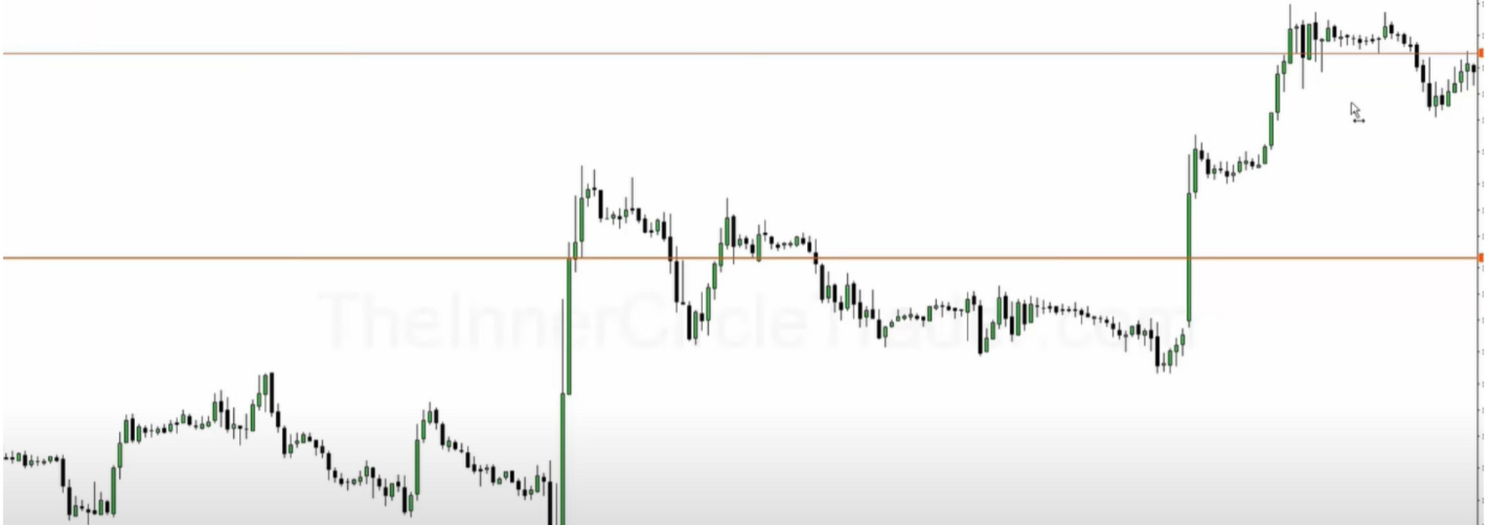

He uses the actual low of the downcandle here not just the body, so the low of the wick

The whole downcandle represents the mitigation block, so as long as its not trading above that then its respecting it

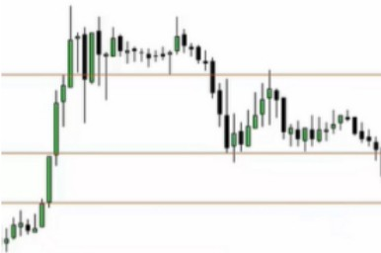So we can be a seller at the lowest point of the candle, the wick. And our stop loss can be at the highest point of the downcandle, also the wick on the opposite side.

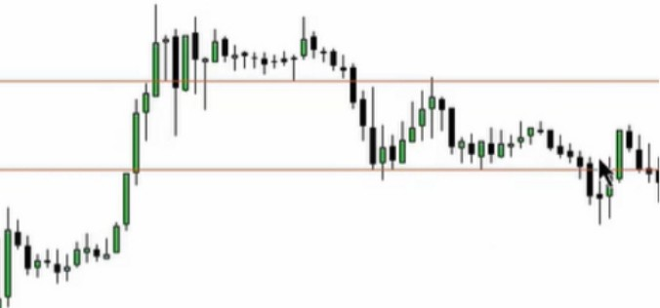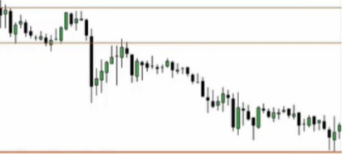

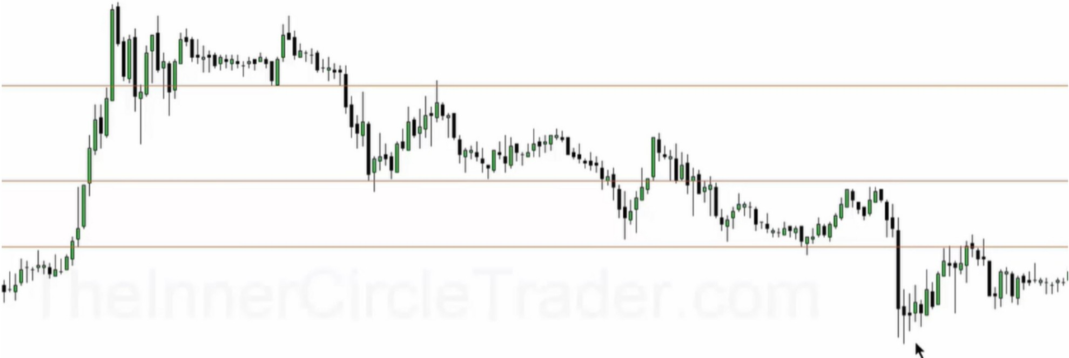

**The** downcandles gets respected

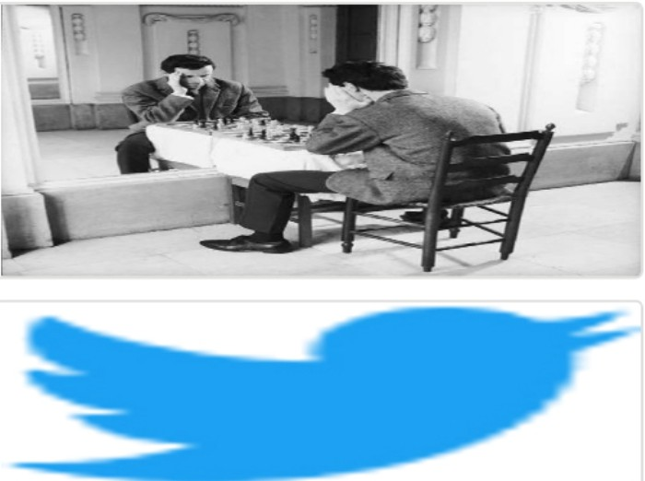Arjo I Twitter, lnstagram I Linktree

Linktree. Make your link do more.

, https://t.co/HhmmTN1fUI

JavaScript is not available.

***"!JI*** https://twitter.com/arjoio